**What is the *t*-distribution?**

The *t-*distribution describes the standardized distances of sample means to the population mean when the population standard deviation is not known, and the observations come from a normally distributed population.

**Is the *t-*distribution the same as the Student’s *t*-distribution?**

Yes.

**What’s the key difference between the *t-* and z-distributions?**

The standard normal or z-distribution assumes that you know the population standard deviation. The *t-*distribution is based on the sample standard deviation.

***t*-Distribution vs. normal distribution**

The *t*-distribution is similar to a normal distribution. It has a precise mathematical definition. The useful properties of the *t-*distribution and why it is important in analyses.

* Like the normal distribution, the *t-*distribution has a smooth shape.
* Like the normal distribution, the *t-*distribution is symmetric. If you think about folding it in half at the mean, each side will be the same.
* Like a standard normal distribution (or z-distribution), the *t-*distribution has a mean of zero.
* The normal distribution assumes that the population standard deviation is known. The *t-*distribution does not make this assumption.
* The *t-*distribution is defined by the *degrees of freedom*. These are related to the sample size.
* The *t-*distribution is most useful for small sample sizes, when the population standard deviation is not known, or both.
* As the sample size increases, the *t-*distribution becomes more similar to a normal distribution.

Consider the following graph comparing three *t-*distributions with a standard normal distribution:

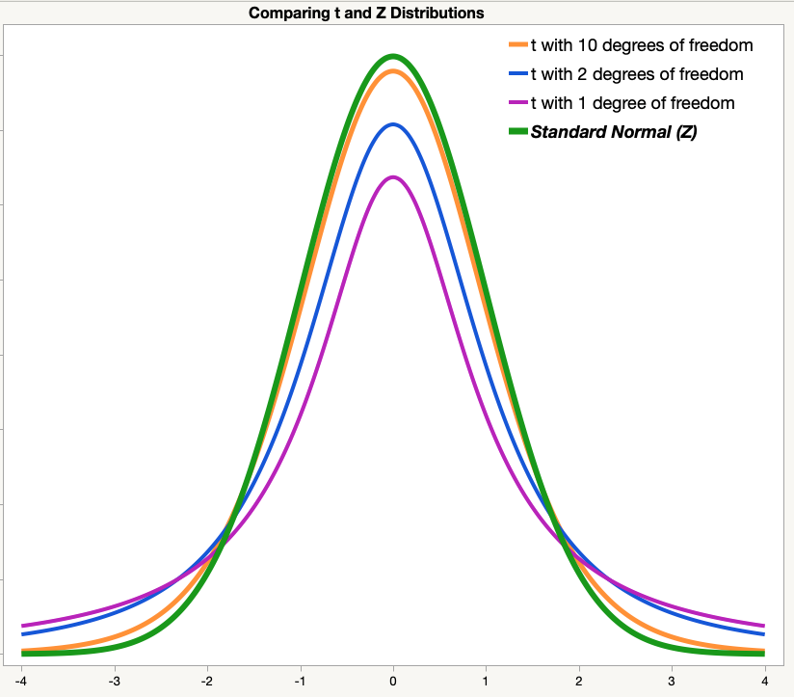

All of the distributions have a smooth shape. All are symmetric. All have a mean of zero.

The shape of the *t-*distribution depends on the degrees of freedom. The curves with more degrees of freedom are taller and have thinner tails. All three *t-*distributions have “heavier tails” than the z-distribution.

A common rule of thumb is that for a sample size of at least 30, one can use the z-distribution in place of a t-distribution. Figure 2 below shows a t-distribution with 30 degrees of freedom and a z-distribution. The figure uses a dotted-line green curve for z, so that you can see both curves. This similarity is one reason why a z-distribution is used in statistical methods in place of a t-distribution when sample sizes are sufficiently large.

